**Introduction to Artificail Intelligence(IAI)**

Table of Contents

Introduction 1

Introduction | AI | Lec-01 1

Screenshot-1 1

Screenshot-2 2

Why & Goals | Lec-02 2

Screenshot-1 2

# Introduction

YouTube [link](https://www.youtube.com/playlist?list=PLrjkTql3jnm_yol-ZK1QqPSn5YSg0NF9r)

## Introduction | AI | Lec-01

### Screenshot-1

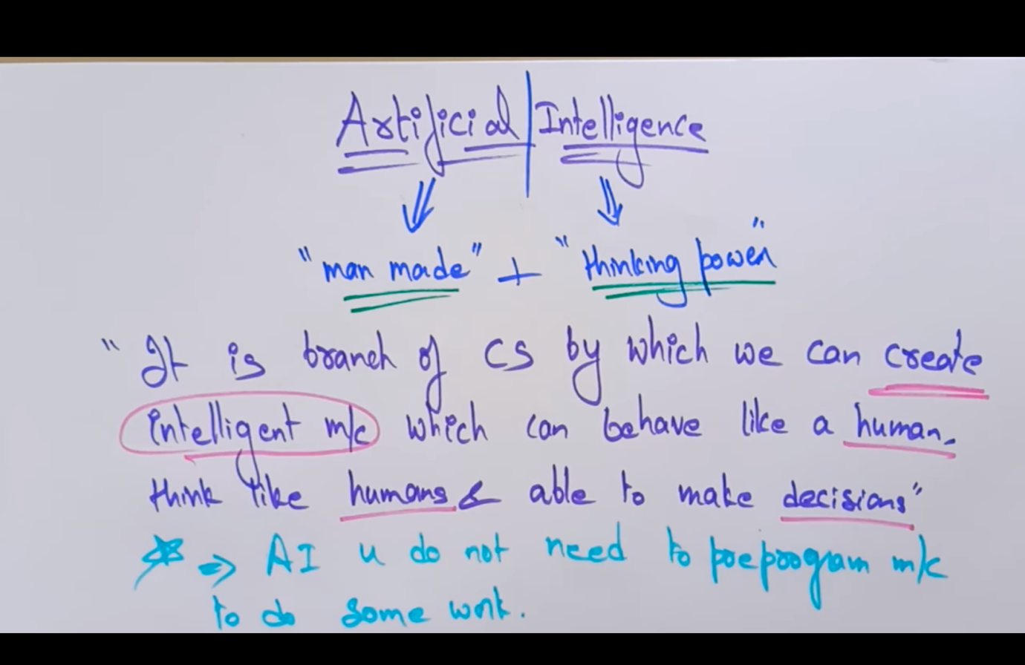

### Screenshot-2

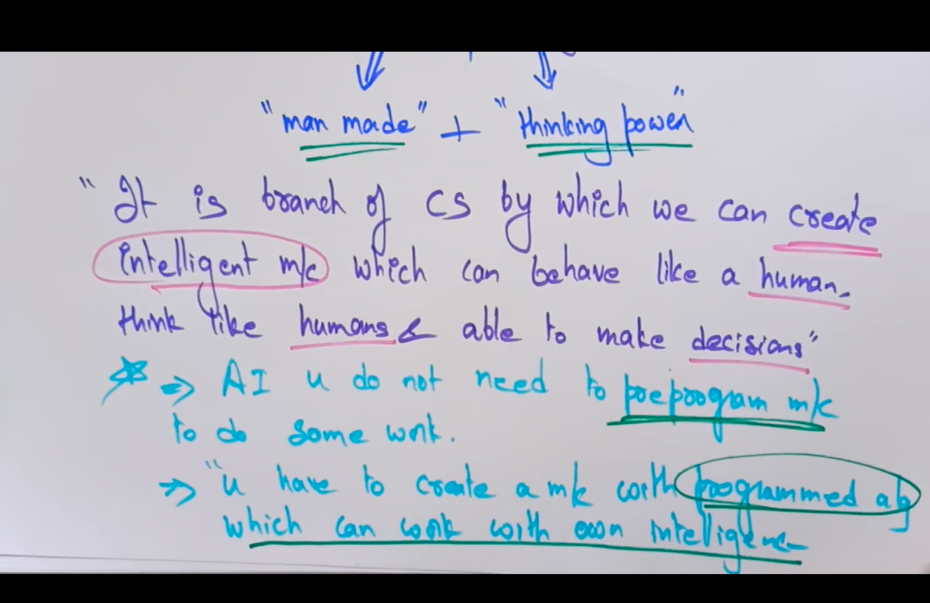

## Why & Goals | Lec-02

### Screenshot-1